SIXTEENTH DR. AMITABH CHOWDHURY ANNUAL MEMORIAL LECTURE
WASTE MANAGEMENT FOR BETTER HEALTH
BY: MRS.ALMITRA H.PATEL
DATE: THURSDAY THE 19.12.2019

Hii do you all hear me? Goodevening! I am very grateful to the loving family of Dr. Amitabh Chowdhury, for inviting me to remember him with this Lecture and to talk on a subject which he would have loved- “Improving Public Health through citizen participation”!
I wonder how many of you here, have visited Boragaon?
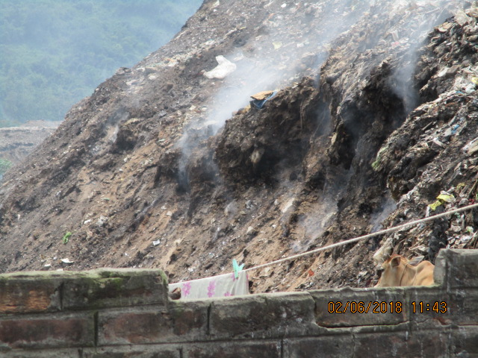

This is where all your waste goes every day, 450 tons of it and we are sending plastic there, causing smoke and fires and ill health that spreads all over the city. This pollution affects all of us -humans, animals and the environment and methane which is disturbing our climate and affecting all of us and Lechate which is going not only into our ground water, but also into your precious Deeepor Beel, something which all of you are privileged to be custodians of. It is a common site at the dump, to see Cows competing for space to eat food with Waste pickers who are trying to collect dry waste to feed their family.

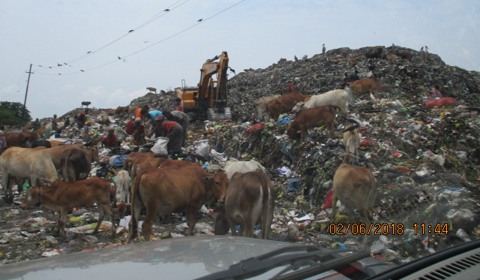

Why do we have to do it this way why can’t we just keep the wet waste separate to feed the animals or the farms, and give our dry waste to our local waste pickers or the Kabbadiwalas, to improve their livelihood?
We may wonder how all this happened and why? From Vedic times till 1970, India had no garbage dumps, in India, at all. There were some small pits, which individual farmers had for their wastes that went the next season to their fields. So, there were no dumps because farmers collected everything from villages, towns and even cities. All household discards were only food wastes. Farmers collected it all to compost it and use its nutrients to enrich their soils. The Plastic Age destroyed this practice. Plastics blanketed the fields to keep the rain out of soil, and prevented seeds from sprouting. So Cities began dumping unwanted discards in heaps which grew huge & airless.
THE SOLUTION IS IN OUR HANDS : KEEP WASTES UNMMIXED !
Send unmixed food waste to animals or farms
Give plastics to waste-pickers in your lane, once a week. Help feed their families.
Compost garden wastes at home and fallen leaves in local parks.
Do not mix broken glass in Wet or Dry Waste.
Protect waste workers through its collection once a year, or keep hundis for glass for annual sale as temple donations.

Guwahati’s 1 million population sends 450 tons a day of mixed waste to Boragaon. Its 50 tpd compost plant burnt down when piles of removed plastic caught fire
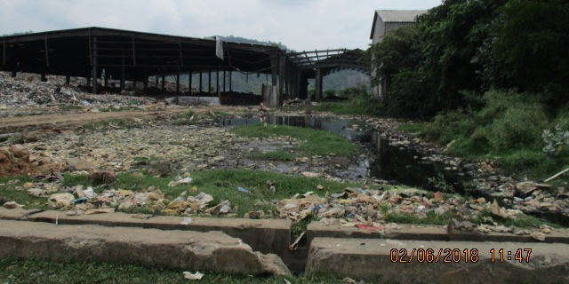
SEND ONLY WET WASTE THERE TO STABILISE IN WINDROWS SPRAYED WITH BIO-CULTURES
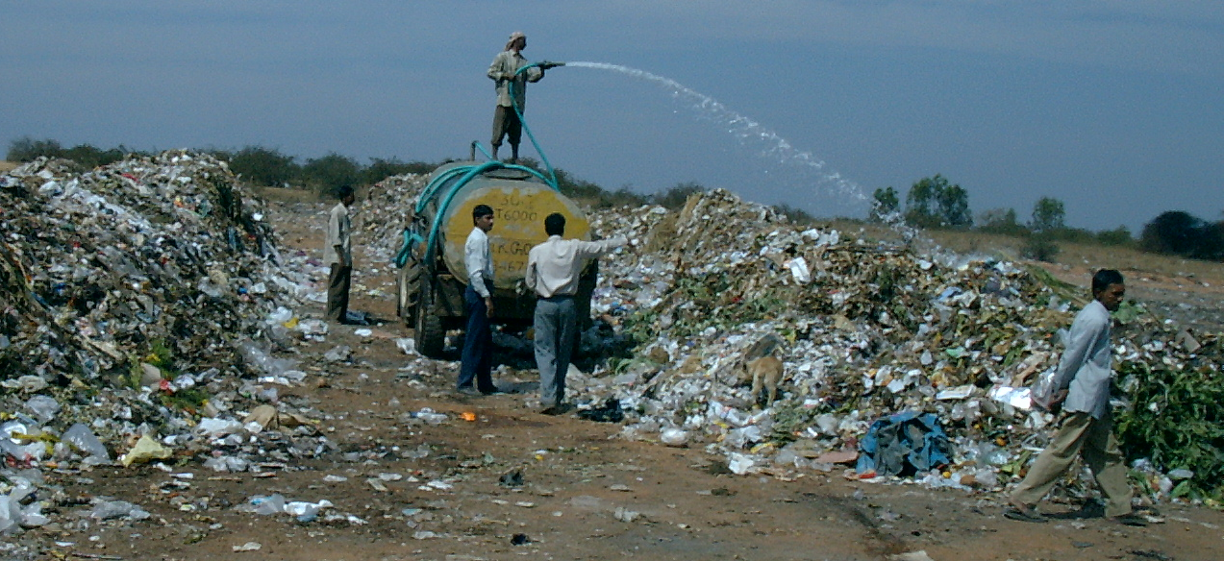
TAMIL NADU TOWNS HAVE MINIMISED WASTE TO DUMPS BY WARD-WISE COMPOSTING OF 5 TONS A DAY WET WASTE

HOW T.N. ACHIEVED THIS?
The MLA, DC, Mpl Cmr, Police Chief posted images of themselves keeping wet, dry and saniwastes unmixed.
Every municipal and government employee was required to do the same.
Every school and college teacher obtained a pledge signed by students and parents, promising to keep their wastes unmixed.
All religious leaders of every faith spread the message in their weekly sermons.
Doctors saw steep drops in patient numbers
DRY WASTE IS SORTED AT MICRO-COMPOSTING CENTRES
All types are baled and sent to different recyclers
MLP=Multi-Layer Packaging is not recyclable.
A win-win solution is to shred and sprinkle them
onto stones on the conveyor of hot-mix plants.
On heating, the plastic flakes soften to form a baked-on primer coat of polymer on stones.
Molten bitumen bonds much better to this. Such
Plastic Roads give 2-3 times longer tar road life,
no pot-holes. Contractors save on maintenance.
STABILISE ALL FRESH WASTE IN WIND-ROWS
Spreading in thin layers takes a lot of space
So unload the waste in long parallel heaps
max 2 meters high, so sides can have air.
These are called wind-rows, so that wind
can blow between rows to aerate the waste
BRING DOWN OLD WASTE HEAPS BY BIO-MINING. SLICE DOWN FROM TOP TO LET IN AIR, SPRAY THE SIDES WITH BIOCULTURE
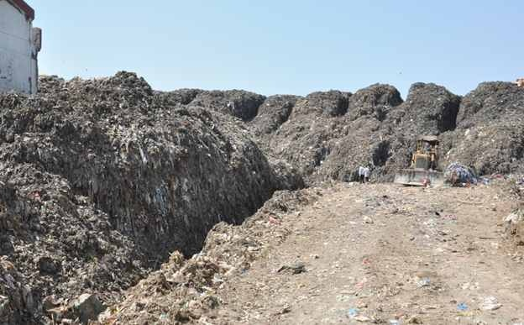
DRAIN OUT LEACHATE AND BIO-TREAT IT. WHEN WASTE IS DRY ENOUGH, SCREEN INTO SIZED FRACTIONS FOR DIFFERENT USES
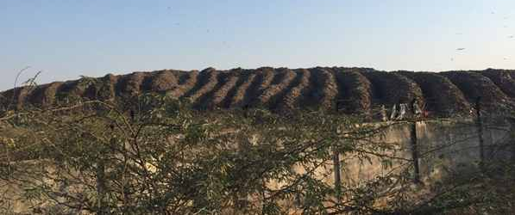
MINIMISE SEWAGE SLUDGE
Stop using phenyle & chlorine cleaners
which kill the friendly microbes we need
in septic tanks to digest human waste.
Use a little liquid soap instead and save
a lot on frequent septic tank cleanout.
Bio-treat Pamohi Channel sewage at Garchuk Boragaon bridges before it pollutes Deepor Beel.
HELP MINIMISE DISEASES
Keep wastes unmixed.
Give dry wastes to waste-pickers
NO BURNING of any wastes or leaves for disposal or warmth.
Cooperate with city for decentralised waste processing funded by savings on secondary transport to disposal site
Lead by example and spread the word !

Thank you!

